Yuva Intern

Week 2 Technical Report
Data Preprocessing, Cleaning, and Transformation for Agricultural Data
Junior Machine Learning Data Analyst: Agriculture & Agribusiness
Student | Atharv Vyahalkar
Internship role | Junior Machine Learning Data Analyst: Agriculture & Agribusiness
Dataset | Crop Data 24-25.csv (district-level crop statistics, 2024-25)
Report | Week 2
Submission date | October 2026

Contents
Executive Summary 4
1. Introduction 4
2. Week 2 Objectives 5
3. Dataset and Data Sources 5
3.1 Dataset provenance 5
3.2 Dataset overview 6
3.3 Data dictionary 7
4. End-to-End Data Preprocessing Pipeline 7
5. Initial Data Quality Assessment 8
5.1 Shape and structure 8
5.2 Data types 9
5.3 Missing values 9
5.4 Duplicate checks 9
5.5 Categorical and numerical summaries 9
6. Missing-Value Analysis and Treatment 10
6.1 Problem 10
6.2 Investigation 10
6.3 Decision and rationale 10
6.4 Result 11
7. Data Cleaning versus ML-Oriented Restructuring 11
8. Categorical and Structural Analysis 12
8.1 Label consistency 12
8.2 Individual versus aggregate crops 12
8.3 Total-season analysis 13
8.4 Modelling implications 13
9. Outlier Detection and Interpretation 14
9.1 IQR methodology 14
9.2 Descriptive statistics 14
9.3 IQR results 15
9.4 Interpreting the flagged observations 15
9.5 Extreme observations 15
9.6 Aggregate versus individual crops 15
9.7 Final outlier decision 17
10. ML-Oriented Dataset Construction 17
10.1 Cleaning versus restructuring 17
10.2 Exclusion criteria 17
10.3 Dataset lineage 17
10.4 Result 18
11. Categorical Encoding 18
12. Numerical Transformation and Before/After Analysis 19
12.1 Initial distributions 19
12.2 Choice of log1p 20
12.3 Before/after transformation analysis 20
13. Standardization 21
14. Final ML-Ready Feature Matrix 22
14.1 Feature lineage 22
14.2 Final dataset composition 23
14.3 Sample of the final CSV 23
14.4 What "ML-ready" means in this project 23
15. Final Validation 24
16. Before and After Summary 25
17. Key Analytical Findings 26
18. Challenges and Decision Log 27
19. Relevance to Machine Learning 27
20. Data Leakage and Future Modeling Considerations 28
20.1 Target leakage among Area, Production and Yield 28
20.2 Preprocessing leakage and the correct workflow 28
20.3 Status in Week 2 28
21. Limitations 28
22. Conclusion 29
References 30
Appendix A. Selected Preprocessing Code 31
Appendix B. Supplementary Tables 32
Appendix C. Raw-to-Final Dataset Verification 34
C.1 Verification of the final CSV 34
C.2 Numerical consistency checklist 35
C.3 Checks performed only during report preparation 35

Executive Summary
Week 2 moves the 2024-25 district-level crop dataset from exploration (Week 1) to preparation for machine learning. The raw file, Crop Data 24-25.csv, holds 25,239 records and 7 columns: State, District, Crop, Season, and the numerical fields Area-2024-25, Production-2024-25 and Yield-2024-25. This report follows the data from that file to the final feature matrix, Agricultural_ML_Ready_Week2.csv, and explains what changed at each stage and why. Both CSV files were loaded and checked independently while the report was prepared, and the numbers below were reconciled against the notebook outputs.
Cleaning. The raw file has 94 missing cells, all in 47 rows where Production and Yield are both blank. Removing those 47 rows (0.19%) gives a cleaned source dataset of 25,192 rows. Label columns showed no whitespace or case inconsistencies, and there are no duplicate rows. No row was removed for being a statistical outlier.
Structure. Crop mixes 15 individual crops with four aggregate categories (8,113 records, 32.2%), and Season contains Total (10,143 records, 40.26%) next to Kharif, Rabi and Summer. These records are valid source data, but they overlap with the individual-crop and seasonal records. For the 7,284 individual-crop Total-season rows, Area and Production equal the sum of the seasonal rows within rounding tolerance (a check made during report preparation, not in the notebook).
Outliers. The IQR rule flagged 3,903 Area values (15.49%), 4,299 Production values (17.06%) and 485 Yield values (1.93%). The high Area and Production rates reflect a distribution in which at least half the values are almost zero, so the upper fences sit at only 0.725 and 1.5. The largest Area and Production values are district totals for Total Food Grains and Cereals in large or high-output districts. The outliers were retained and the skew was handled by transformation.
ML-oriented restructuring. Excluding aggregate crops and Total-season rows (8,113 + 7,284 = 15,397 rows) leaves 9,795 non-overlapping crop-season-district observations covering 31 states, 723 districts, 15 crops and 3 seasons. One-hot encoding of the four categorical columns produced 772 binary features. The log1p transformation reduced skewness from 4.9450, 5.0871 and 1.8942 to 3.0746, 2.9391 and -0.9452 for Area, Production and Yield, and StandardScaler then standardized the three columns.
Final output. The final dataset has 9,795 rows and 775 columns (772 encoded features and 3 standardized numerical features), with 0 missing values, 0 infinite values and 0 duplicate rows. It is a preprocessed feature matrix, not a supervised-learning dataset: no target variable was selected, and the encoder and scaler were fitted on the complete ML-oriented dataset. Target selection, a train/test split and leakage-safe fitting of the transformers are later steps.

1. Introduction
Public agricultural statistics are published to report what happened in each district, crop and season, not to suit a learning algorithm. The 2024-25 crop file illustrates the gap. It reports Area, Production and Yield by district, crop and season, but it also carries pre-computed totals, a season called Total, 47 records without production figures, and numerical columns in which most values are tiny and a few are large. Fed directly into a model, those features would distort what it learns.
Week 1 was exploratory analysis of this dataset. Week 2 uses that understanding to make decisions about the data: which records to keep, which to set aside for modelling, how to represent categories numerically, and how to bring three differently scaled numerical columns onto a common footing. Each decision in this report follows one pattern: the problem, the investigation, the evidence, the decision, the rationale and the result.
One distinction runs through the whole report. Removing the 47 records with missing production figures is data cleaning, because those records are incomplete. Excluding aggregate crops and Total-season rows is a different kind of step: those rows are complete and legitimate, but they are inappropriate for one particular modelling representation. Section 7 develops this.

2. Week 2 Objectives
The Week 2 task asks for the items below. Each is addressed in the section shown.
Table 1. Week 2 requirements and where they are addressed
Requirement | Addressed in
Data understanding and quality assessment | Sections 3 and 5
Missing-value handling | Section 6
Cleaning versus ML-oriented restructuring | Sections 7 and 10
Structural and category analysis | Section 8
Outlier detection and interpretation | Section 9
Categorical encoding | Section 11
Numerical transformation and before/after comparison | Sections 12 and 16
Normalization / standardization | Section 13
Final ML-ready feature matrix and validation | Sections 14 and 15
Documentation of methodology and decisions | Sections 4, 17 and 18
Preparation for future ML applications, leakage and limitations | Sections 19 to 21

3. Dataset and Data Sources

3.1 Dataset provenance
The supplied file is Crop Data 24-25.csv (1,771,680 bytes). Neither the notebook nor the task materials name its publisher, so a check was made on 25 October 2026 to see whether it can be linked to a published resource.
A file with an identical header (State, District, Crop, Season, Area-2024-25, Production-2024-25, Yield-2024-25), named DES-District-Data-For-2024-25.csv, is offered on the "Latest Agriculture Statistics of India" page of the Global Agriculture magazine (Krishak Jagat). The page lists it as "All India: District and Crop wise Area, Production & Yield of All Crops (2024-25)", credits the source as DA&FW (Department of Agriculture & Farmers Welfare), and states the units as lakh hectares, lakh tonnes and kg per hectare. The prefix DES in the file name presumably refers to the Directorate of Economics and Statistics; that is an inference. I compared 27 rows from the Punjab section of the hosted file, which was the portion available for retrieval, with the supplied CSV. All 27 agree exactly on Area, Production and Yield.
Table 2. Provenance verification status
Item | Status
Header and column order | Identical to the hosted file
Row-level agreement | 27 of 27 Punjab rows compared match exactly; the full file was not compared
Stated origin of the hosted file | DA&FW, as credited by the hosting page
Hosting page | Secondary publisher (Global Agriculture / Krishak Jagat), not a government portal
Primary-portal URL on a government site | Not located; not claimed
Download date of the student's copy | Not recorded in the supplied materials
UPAg or data.gov.in resource | No mapping to the supplied file was established; not claimed

The supplied file is therefore consistent with, and very probably a copy of, the published 2024-25 district-level dataset credited to DA&FW. The report cites that hosting page as the located publication. It does not present the original government portal as independently confirmed.

3.2 Dataset overview
Table 3. Dataset overview
Attribute | Description
File | Crop Data 24-25.csv
Records | 25,239
Variables | 7
Geographic level | State and district (31 states and union territories, 723 districts)
Time period | Agricultural year 2024-25 (single year)
Categorical variables | State, District, Crop, Season
Numerical variables | Area-2024-25, Production-2024-25, Yield-2024-25
Crop labels | 19: 15 individual crops and 4 aggregate categories
Season values | Kharif, Rabi, Summer, Total
Numerical precision | Area and Production carry two decimal places in the supplied file (for example 0.29, 24.98); Yield is a whole number

3.3 Data dictionary
Table 4. Data dictionary
Variable | Type | Description | Role | Unit (verification status)
State | Categorical | State or union territory | Geographic feature | None
District | Categorical | District | Geographic feature | None
Crop | Categorical | Individual crop or aggregate crop category | Categorical feature; defines aggregation level | None
Season | Categorical | Kharif, Rabi, Summer, or Total of the seasons | Categorical feature; defines aggregation level | None
Area-2024-25 | Numerical | Cultivated area | Numerical feature or candidate target | Lakh hectares (stated by host; unverified at source)
Production-2024-25 | Numerical | Production | Numerical feature or candidate target | Lakh tonnes (stated by host; unverified at source)
Yield-2024-25 | Numerical | Production per unit area | Numerical feature or candidate target | kg per hectare (stated by host; unverified at source)

The units are not given in the CSV itself. The hosting page states them, and the data are consistent with them in one respect that could be tested. For the 2,980 cleaned rows with Area of at least 1.0, Production divided by Area, multiplied by 1,000, agrees with the reported Yield to within 5% in every row (median deviation 0.14%). This supports Yield being in kg per hectare when Area and Production share a scale, but it cannot by itself distinguish lakh from other scales. The units are therefore treated as stated by the host, not confirmed at the source, and the report does not rely on them for any calculation.

4. End-to-End Data Preprocessing Pipeline
The table below classifies each stage, and Figure 1 shows the pipeline. Colour in the figure marks the type of step: cleaning changes the source dataset, analysis examines it without changing it, and ML transformation builds a modelling representation.
Table 5. Pipeline stages and their classification
Stage | Type | Outcome
Raw data | Input | 25,239 × 7
Initial profiling | Analysis | Shape, types, missing values, duplicates, cardinality
Missing-value analysis | Analysis | 47 incomplete records characterized
Data cleaning | Cleaning | 47 records removed: 25,192 × 7
Structural analysis | Analysis | Aggregate crops and Total season identified
Outlier analysis | Analysis | Outliers flagged and retained
ML-oriented restructuring | ML transformation | Aggregate and Total-season rows excluded: 9,795 × 7
Categorical encoding | ML transformation | 772 one-hot features
Numerical transformation | ML transformation | log1p on three columns
Standardization | ML transformation | StandardScaler on three columns
Validation | Verification | 0 missing, 0 infinite, 0 duplicate
Final ML-ready feature matrix | Output | 9,795 × 775

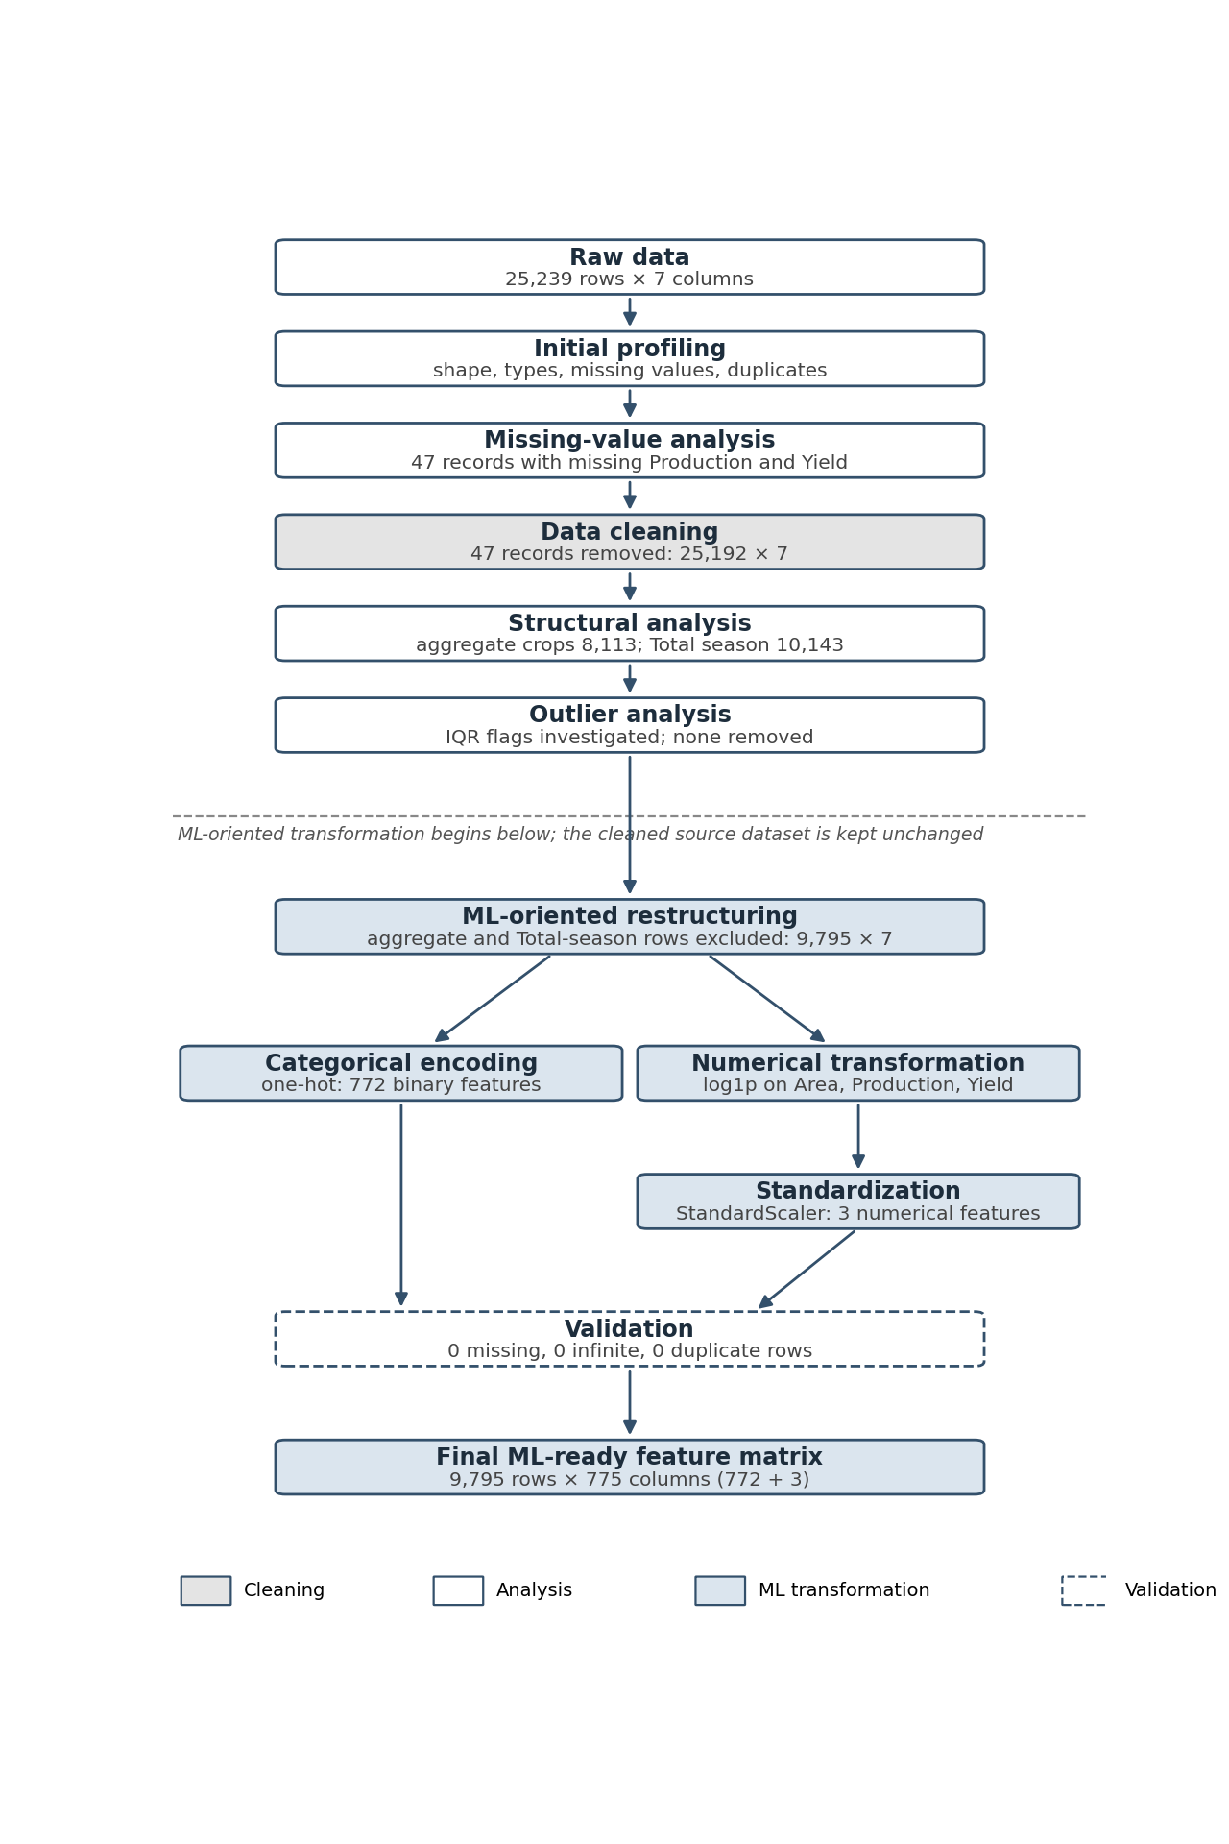
Figure 1. End-to-end preprocessing pipeline with dataset dimensions. Grey marks cleaning, white marks analysis, blue marks ML-oriented transformation and the dashed box marks validation; the dashed line separates source-data preparation from modelling-specific steps.

5. Initial Data Quality Assessment
The notebook loaded the file and inspected its shape and first and last rows before changing anything, so that every later change can be measured against a known starting point. The checks below were repeated on the raw CSV while the report was prepared.

5.1 Shape and structure
The raw dataset has 25,239 rows and 7 columns, as printed in the notebook and confirmed from the CSV. The first rows belong to the Nicobars district of the Andaman and Nicobar Islands and the last to Uttar Dinajpur in West Bengal.
Table 6. Representative rows of the raw dataset
Row | State | District | Crop | Season | Area | Production | Yield
0 | Andaman And Nicobar Islands | Nicobars | Rice | Kharif | 0.00 | 0.00 | 735
1 | Andaman And Nicobar Islands | Nicobars | Rice | Total | 0.00 | 0.00 | 735
2 | Andaman And Nicobar Islands | Nicobars | Cereals | Kharif | 0.00 | 0.00 | 735
25237 | West Bengal | Uttar Dinajpur | Total Food Grains | Summer | 1.10 | 6.43 | 5,845
25238 | West Bengal | Uttar Dinajpur | Total Food Grains | Total | 3.98 | 17.30 | 4,341

Two features of these rows shaped later decisions. The same district and crop appear under a specific season and again under Total with identical values (rows 0 and 1), and aggregate labels such as Cereals and Total Food Grains sit in the same column as Rice. Also, rows 0 to 2 show an Area and Production of 0.00 with a Yield of 735; across the cleaned data, 8,603 of the 8,620 rows with an Area of 0.00 have a positive Yield. This is consistent with Area and Production being rounded to two decimals while Yield was computed from unrounded values. It is an interpretation, discussed again in Section 21.

5.2 Data types
The four categorical columns are text and the three numerical columns are float64. Neither fact is printed in the notebook screenshots supplied; both were read from the CSV for this report.

5.3 Missing values
Production-2024-25 and Yield-2024-25 each have 47 missing values (94 missing cells in total, in 47 rows). All other columns, including Area, are complete. The notebook's before/after comparison shows the same counts.

5.4 Duplicate checks
The raw CSV has 0 fully duplicated rows, and every combination of State, District, Crop and Season occurs exactly once, so each row is a distinct observation. In the notebook the duplicate check appears only at the final validation stage; the raw-data check was performed for this report.

5.5 Categorical and numerical summaries
Table 7. Initial structure of the raw dataset
Check | Result
Shape | 25,239 rows × 7 columns
Data types | 4 text columns, 3 float64 columns
Missing values | Production 47, Yield 47, all other columns 0
Duplicate rows | 0
Cardinality | State 31, District 723, Crop 19, Season 4

Table 8. Numerical summary of the raw dataset
Variable | Count | Mean | Std | Min | 25% | 50% | 75% | Max
Area-2024-25 | 25,239 | 0.3421 | 0.7422 | 0.00 | 0.00 | 0.02 | 0.29 | 8.93
Production-2024-25 | 25,192 | 0.9016 | 2.1183 | 0.00 | 0.00 | 0.03 | 0.60 | 24.98
Yield-2024-25 | 25,192 | 1,973.58 | 1,411.50 | 0.00 | 892.75 | 1,614.00 | 2,788.00 | 15,033.00

The counts show the 47 missing Production and Yield values directly. The summaries were computed from the raw CSV; the notebook's describe() output was produced after cleaning (Section 9.2). In all three columns the mean sits well above the median (Area 0.34 against 0.02), which is the first sign of the right skew treated in Section 12. Of the categorical columns, Crop has the most uneven structure, with 19 labels of which four are aggregates (Section 8).

6. Missing-Value Analysis and Treatment

6.1 Problem
Production and Yield are blank in 47 rows. A model cannot be trained on rows with missing numerical features, so each such row has to be completed, ignored or removed, and the right choice depends on why the values are missing.

6.2 Investigation
- The two columns fail together. Both are missing in the same 47 rows, so the problem is a missing production record, not a missing yield alone.
- Area is zero or small. Describing Area for these 47 rows gives a mean of 0.003830, a median of 0.00 and a maximum of 0.05. In 43 rows Area is 0.00 and in 4 rows it is above zero.
- The four positive-Area rows are one pattern. They are Jowar in Unnao (Area 0.04) and Varanasi (Area 0.05) in Uttar Pradesh, each in Kharif and Total. The notebook checked these four specifically and confirmed Production and Yield are blank in all of them.
- By season: Total 20, Kharif 18, Rabi 9. By state: Chhattisgarh 14, Rajasthan 11, West Bengal 5, Bihar 5, Uttar Pradesh 4, and Arunachal Pradesh, Himachal Pradesh, Jharkhand and Madhya Pradesh 2 each. By crop: Ragi 8, Moong 7, Lentil 6, Bajra, Jowar and Tur 4 each, and eight crops with one or two records each (Appendix B).
Table 9. Profile of the 47 records with missing Production and Yield
Dimension | Distribution
Area = 0.00 | 43 records
Area > 0 | 4 records (Area 0.04 to 0.05)
Season | Total 20; Kharif 18; Rabi 9
State | 9 states; Chhattisgarh 14 and Rajasthan 11 account for 25 of the 47
Crop | 14 crop labels; one is an aggregate category (Nutri/Coarse Cereals, 2 records)

6.3 Decision and rationale
The 47 rows were removed with dropna on the two affected columns. Imputation was considered and rejected. The source gives no production figure for these crop-district-season combinations, and Area is zero or very small, so there is no cultivated quantity from which a production could be estimated. An imputed Production, and the Yield derived from it, would be invented numbers placed in two of the three numerical columns. If the units stated by the host apply, an Area of 0.00 at two-decimal precision means less than 0.005 lakh hectares, so the records are small but not necessarily empty. Even the four Jowar rows, whose Area of 0.04 to 0.05 is larger, lack the production figure that would make them usable, and four rows do not justify a special imputation rule. The loss is 0.19% of the dataset. Treating the missing values as a plausible zero was also rejected: a zero Production alongside a positive Area would be a substantive claim about the harvest, and the source did not make it.

6.4 Result
Table 10. Dataset quality before and after missing-value treatment
Metric | Before | After
Rows | 25,239 | 25,192
Rows removed | not applicable | 47 (0.19%)
Missing Production values | 47 | 0
Missing Yield values | 47 | 0
Missing cells in total | 94 | 0
Columns | 7 | 7

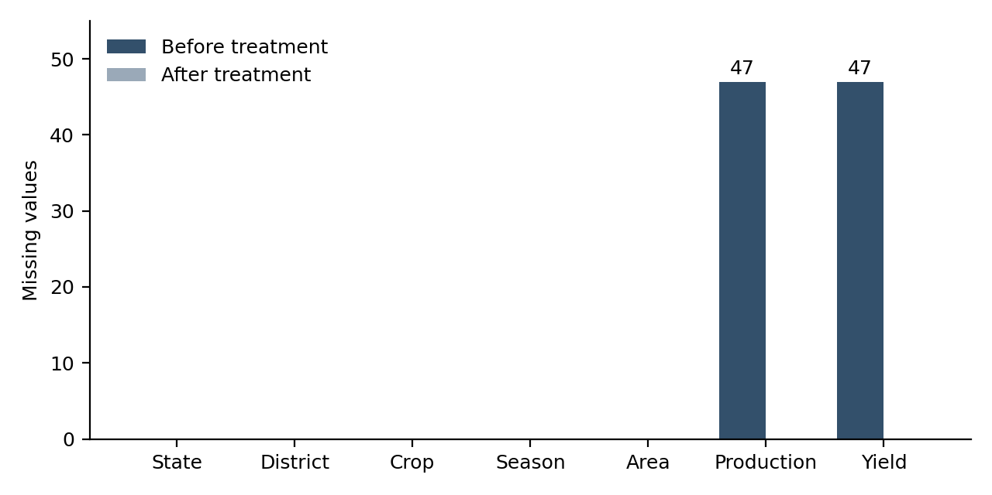
Figure 2. Missing values by column before and after treatment. Only Production-2024-25 and Yield-2024-25 were affected, with 47 missing values each; every column is complete after the 47 records were removed.
After treatment every column reports 0 missing values, and the cleaned source dataset has 25,192 rows and 7 columns. The rows removed equal the difference in row counts (47).

7. Data Cleaning versus ML-Oriented Restructuring
Two different kinds of change are made to the data in this project, and they have different purposes. Cleaning makes the source dataset internally usable. ML-oriented restructuring makes a selected representation of it suitable for modelling. A record can be valid in the original agricultural reporting dataset and still be inappropriate for a particular machine-learning representation, because it aggregates or duplicates information that other records already contain.
Table 11. Cleaning compared with ML-oriented restructuring
Process | Purpose | Example from this project
Cleaning: missing-value identification and treatment | Remove incomplete records that cannot be used | 47 records without Production and Yield removed (25,239 to 25,192)
Cleaning: duplicate, data-type and label checks | Confirm the source is internally consistent | 0 duplicate rows; 0 whitespace or case inconsistencies
Analysis: structural and outlier analysis | Understand the data without altering it | Aggregate crops, Total season and IQR outliers examined; no row removed
Restructuring: exclusion of aggregate crops | Remove overlap between aggregation levels | 8,113 aggregate-crop records excluded from the modelling representation
Restructuring: exclusion of Total-season records | Remove duplication of seasonal production | 7,284 individual-crop Total-season records excluded
Restructuring: one-hot encoding | Represent nominal categories numerically | 772 binary features
Restructuring: log1p and standardization | Reduce skew and equalize scale | Skewness reduced; each column mean 0, standard deviation 1

The two stages leave different objects behind. Cleaning produces the cleaned source dataset (25,192 rows), which keeps every valid record, aggregates and Total-season rows included. Restructuring produces the ML-oriented dataset (9,795 rows) and then the feature matrix (9,795 × 775). Records excluded in restructuring are not bad data, and the cleaned dataset remains available for reporting and descriptive analysis.

8. Categorical and Structural Analysis

8.1 Label consistency
Two checks were run on the cleaned data to find labels that would split one category into two. Comparing each value with its whitespace-stripped version found 0 values with leading or trailing whitespace in State, District, Crop and Season. Grouping values after lower-casing and stripping found no case-normalized duplicates in any column. Spelling variants that differ by more than case and whitespace, such as alternative transliterations of district names, were not tested (Section 21).

8.2 Individual versus aggregate crops
The Crop column has 19 values. The four most frequent labels are Total Food Grains (2,597 records), Cereals (2,525), Nutri/Coarse Cereals (2,292) and Maize (2,026), and three of those four are not single crops. Total Food Grains, Cereals, Nutri/Coarse Cereals and Total Pulses are category totals compiled from other crops in the file. Together they hold 8,113 records (32.2% of the cleaned data); the 15 individual crops hold 17,079 (67.8%). The aggregate rows are not errors: a statistical table reports totals because users want them. The grouping of crops into these categories follows the source's own labels, and the notebook did not verify the arithmetic of each aggregate.
Table 12. Individual and aggregate crop records in the cleaned dataset
Category type | Crop labels | Records | Share
Individual crop | 15 | 17,079 | 67.8%
Aggregate | 4 (Total Food Grains, Cereals, Nutri/Coarse Cereals, Total Pulses) | 8,113 | 32.2%
Total | 19 | 25,192 | 100.0%

8.3 Total-season analysis
Season has four values: Total (10,143 records, 40.26% of the cleaned data), Kharif (7,317), Rabi (5,321) and Summer (2,411). A Total row is the district-crop figure summed over seasons, so each one sits beside the seasonal rows from which it is built.
Table 13. Season distribution in the cleaned dataset
Season | Records | Share
Total | 10,143 | 40.26%
Kharif | 7,317 | 29.04%
Rabi | 5,321 | 21.12%
Summer | 2,411 | 9.57%

To test this relationship rather than assume it, the 7,284 individual-crop Total-season rows were compared with the sum of the same district-crop's Kharif, Rabi and Summer rows. For all 7,284, Area and Production agree with the seasonal sum to within 0.02, which is the order of the two-decimal rounding.
Table 14. Which checks were run where
Check | Performed in
Counts of aggregate records (8,113) and Total-season records (10,143); label whitespace and case checks | Notebook
Total-season rows reconciled with the sum of seasonal rows (7,284 of 7,284 agree within 0.02) | Report preparation, on the supplied CSV
Split of Total-season rows into 2,859 aggregate and 7,284 individual-crop rows | Report preparation, on the supplied CSV

8.4 Modelling implications
A Total Food Grains row for a district contains production already counted in the Rice, Wheat and Maize rows for that district, and a Total-season row repeats production already recorded under Kharif, Rabi or Summer. A model trained on all of them would see the same underlying production several times under different labels, and the numerical distributions would be dominated by large summed values. These records are valid but overlap, which is why they are set aside for modelling in Section 10 and not discarded from the cleaned source dataset.

9. Outlier Detection and Interpretation

9.1 IQR methodology
Outliers were screened with the interquartile range rule on each numerical column of the cleaned dataset. With Q1 and Q3 the 25th and 75th percentiles, values outside the bounds below are flagged:
IQR = Q3 − Q1
Lower Bound = Q1 − 1.5 × IQR
Upper Bound = Q3 + 1.5 × IQR
The rule makes no assumption of normality, which suits columns this skewed. Its weakness matters here: when most values sit close together, the IQR is small and even moderate values fall outside the fences.

9.2 Descriptive statistics
Table 15. Summary statistics of numerical variables, cleaned dataset (n = 25,192)
Variable | Mean | Std | Min | 25% | 50% | 75% | Max
Area-2024-25 | 0.3427 | 0.7427 | 0.00 | 0.00 | 0.02 | 0.29 | 8.93
Production-2024-25 | 0.9016 | 2.1183 | 0.00 | 0.00 | 0.03 | 0.60 | 24.98
Yield-2024-25 | 1,973.58 | 1,411.50 | 0.00 | 892.75 | 1,614.00 | 2,788.00 | 15,033.00

For Area and Production the lower quartile is 0.00 and the median is 0.02 and 0.03, so at least half the records are at or close to zero while the maxima are 8.93 and 24.98. The box plots in Figure 3 show the resulting shape: a box squashed against zero and a long column of points above it.
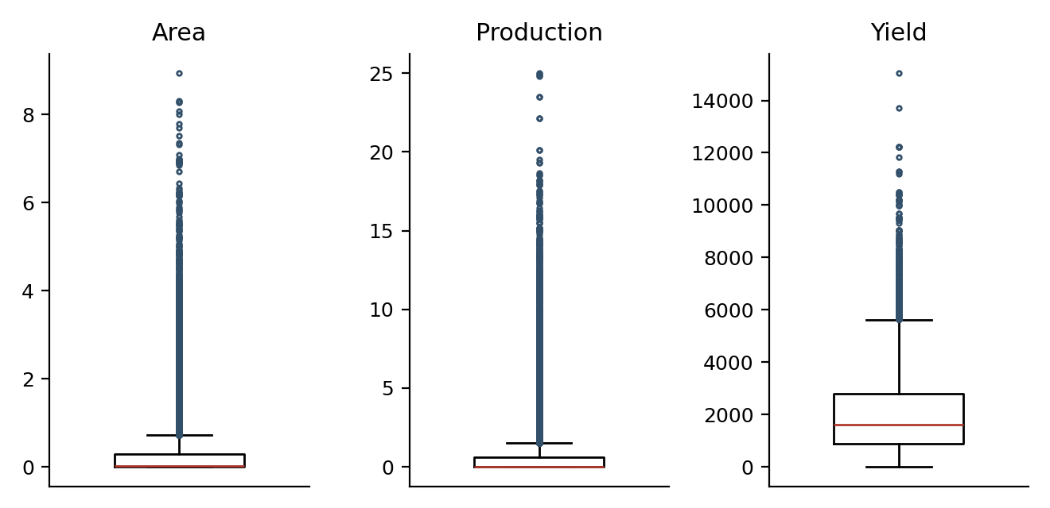
Figure 3. Box plots of Area, Production and Yield in the cleaned dataset, showing the zero-heavy Area and Production distributions with long upper tails; Yield has a wider box and fewer extreme points.

9.3 IQR results
Table 16. IQR outlier detection results, cleaned dataset
Variable | Q1 | Q3 | IQR | Lower bound | Upper bound | Outliers | Percentage
Area-2024-25 | 0.00 | 0.29 | 0.29 | -0.435 | 0.725 | 3,903 | 15.49%
Production-2024-25 | 0.00 | 0.60 | 0.60 | -0.900 | 1.500 | 4,299 | 17.06%
Yield-2024-25 | 892.75 | 2,788.00 | 1,895.25 | -1,950.125 | 5,630.875 | 485 | 1.93%

The IQR rule flagged 3,903 Area observations. Because the lower quartile was zero and the distribution was heavily concentrated near zero, the resulting upper fence was only 0.725. The high flag rate therefore reflects distribution shape and not evidence that 15.49% of the observations are erroneous. No value can be below the negative lower bounds, so only unusually large values are flagged. These counts were reproduced independently from the raw CSV.

9.4 Interpreting the flagged observations
Statistical outlier detection was used as an investigative method rather than an automatic deletion rule. A flagged value is only a value far from the middle of the distribution. In agricultural data that is often a property of what is measured: a large district has a large Area, and an intensive grain district has a large Production. Deleting them would remove the most informative records and bias the dataset toward small plantings.

9.5 Extreme observations
The notebook listed the ten largest values of each variable. All ten Area values are Total Food Grains records, nine in the Total season, in large districts: Churu (8.93), Ahilyanagar (8.30), Narmadapuram (8.29), Raisen (8.28), Barmer (8.08 and 8.01), Bikaner, Kalaburagi, Solapur and Vijayapura. All ten Production values are Punjab records for Total Food Grains or Cereals in the Total season, led by Sangrur (24.98), Ludhiana (24.85) and Bathinda (23.49). These are district totals across all grain crops in some of the largest and most productive grain districts, and not errors on their face.
The Yield extremes are different. The three highest values are 15,033 for Other Pulses in Bikaner (Rabi), 13,717 for Other Pulses in Nalgonda (Rabi) and 12,237 for Maize and Nutri/Coarse Cereals in Dakshin Dinajpur (Summer). Looking up these rows shows that the two pulse records have an Area of 0.00 and a Production of 0.00 or 0.01. Yield is Production divided by Area, so a yield computed from values below reporting precision can be very large and is probably unreliable. These records were kept and flagged for source verification, not altered. The Dakshin Dinajpur record has an Area of 0.02 and a Production of 0.29, a larger base.

9.6 Aggregate versus individual crops
To test whether aggregation explains the extremes, the notebook created a temporary label separating the 8,113 aggregate records from the 17,079 individual-crop records, summarized each group and repeated the IQR test within each group. The label was dropped afterwards so it would not leak into later steps.
Table 17. Summary statistics by crop type (cleaned dataset)
Type | Variable | Median | Mean | Std | Max
Aggregate | Area | 0.22 | 0.6989 | 1.0476 | 8.93
Aggregate | Production | 0.48 | 1.8787 | 2.9833 | 24.98
Aggregate | Yield | 2,460.0 | 2,610.67 | 1,375.43 | 12,237.0
Individual crop | Area | 0.01 | 0.1735 | 0.4517 | 6.95
Individual crop | Production | 0.01 | 0.4374 | 1.3124 | 17.89
Individual crop | Yield | 1,179.0 | 1,670.94 | 1,325.87 | 15,033.0

Aggregate records have a median Area of 0.22, more than twenty times the individual-crop median of 0.01, and a median Production of 0.48 against 0.01. This is the expected effect of summing several crops into one row. Median Yield is also higher for aggregates (2,460 against 1,179), because an aggregate yield is an average over several crops.
Table 18. IQR outliers within each crop type
Type | Variable | Records | Outliers | Percentage
Individual crop | Area | 17,079 | 2,938 | 17.20%
Individual crop | Production | 17,079 | 3,095 | 18.12%
Individual crop | Yield | 17,079 | 631 | 3.69%
Aggregate | Area | 8,113 | 552 | 6.80%
Aggregate | Production | 8,113 | 666 | 8.21%
Aggregate | Yield | 8,113 | 170 | 2.10%

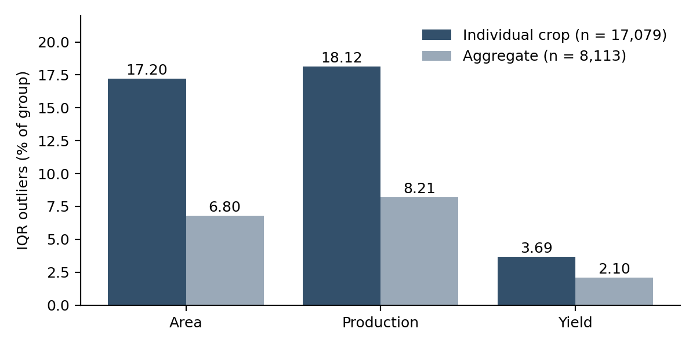
Figure 4. Share of records flagged by the IQR rule within the individual-crop and aggregate groups; individual-crop records have the higher flag rate for Area and Production.
This result runs against the simple assumption that aggregates are the outliers. Within its own group, the individual-crop data has the higher flag rate (17.20% for Area against 6.80%), most likely because its median is 0.01 and its fences are therefore very tight, so modest areas count as unusual. The group-specific counts also do not add up to the pooled counts (2,938 + 552 = 3,490 against 3,903 for Area), which shows that the threshold depends on which records are pooled. The large pooled flag rate is thus a product of a zero-heavy distribution and a mixture of groups at different scales, not of 3,903 errors.

9.7 Final outlier decision
No observations were removed solely because they were statistical IQR outliers. The extreme values were retained as legitimate observations, and the problem they cause for modelling, which is heavy skew, was addressed by transformation (Section 12). Capping or deleting would have altered real production figures to fit a statistical convention. The exclusion of aggregate crops and Total-season rows in Section 10 rests on a different ground: what those records represent, not how extreme they are.

10. ML-Oriented Dataset Construction

10.1 Cleaning versus restructuring
Three different objects appear in this report, and they should not be confused.
- Raw dataset. The original 25,239-row CSV.
- Cleaned source dataset. 25,192 rows after the 47 incomplete records were removed. It preserves all valid source information, including aggregate and Total-season rows, and is the right object for descriptive analysis and reporting.
- ML-oriented dataset. 9,795 rows: a modelling-specific subset of the cleaned dataset in which each row is one non-overlapping observation of an individual crop in one season in one district.
These exclusions are not equivalent to deleting bad data. Aggregate observations were not excluded because they were erroneous. They were excluded because they operate at a different aggregation level and overlap with the individual observations. The cleaned source dataset was not modified by this step; the ML-oriented dataset was built as a copy.

10.2 Exclusion criteria
A single filter was applied to the cleaned data: the Crop must not be one of the four aggregate categories, and the Season must not be Total.
- Aggregate crop records (8,113). They summarize crops that are already present as individual rows, so keeping them would count the same production more than once and add summed Area and Production values that are not crop-level observations.
- Individual-crop Total-season records (7,284). As shown in Section 8.3, these equal the sum of the seasonal rows for the same district and crop.

10.3 Dataset lineage
The two exclusion groups overlap, so they cannot simply be added to the Total-season count. Aggregate crops contain 2,859 Total-season rows, and these are already excluded with the aggregates. The Total-season rows of the dataset (10,143) therefore split into 2,859 aggregate-crop rows and 7,284 individual-crop rows. The rows excluded are the union of the two conditions: 8,113 aggregate-crop rows plus the 7,284 individual-crop Total-season rows, which is 15,397. Figure 5 shows this.
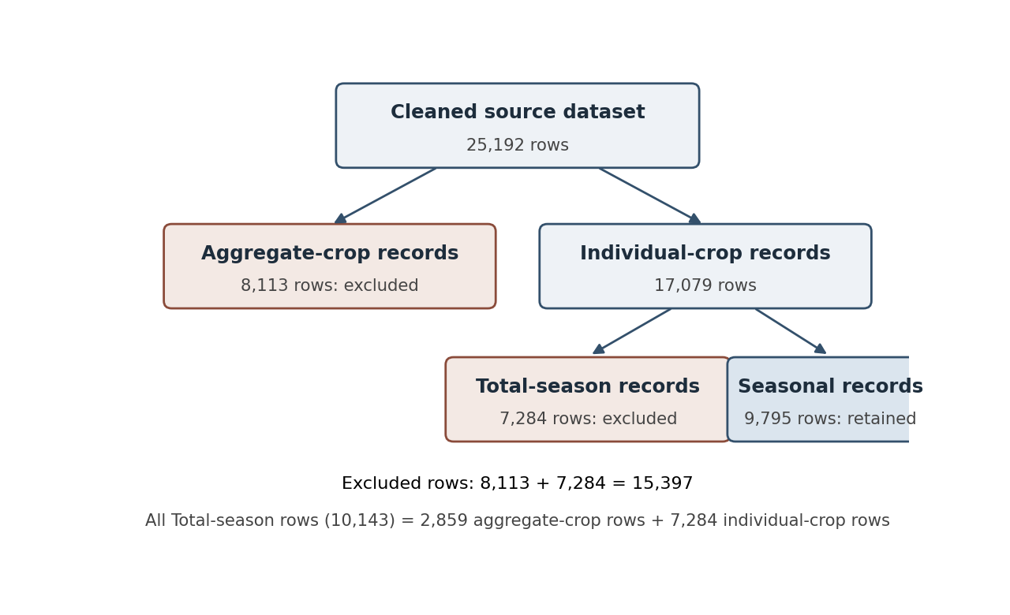
Figure 5. Lineage of the ML-oriented dataset. Aggregate-crop records (8,113) and individual-crop Total-season records (7,284) are excluded, leaving 9,795 seasonal individual-crop records.
The split of the 15,397 excluded rows (2,859 aggregate Total-season, 5,254 aggregate seasonal, 7,284 individual Total-season) was computed from the supplied CSV during report preparation and agrees with the notebook's totals of 8,113, 10,143 and 15,397.

10.4 Result
Table 19. Dataset size and purpose at each preparation stage
Stage | Rows | Columns | Purpose
Raw dataset | 25,239 | 7 | Original source file
Cleaned source dataset | 25,192 | 7 | Internally usable source data; keeps all valid records
ML-oriented dataset | 9,795 | 7 | Non-overlapping modelling representation

The notebook then verified the outcome of the filter: 15 crops remain, the seasons are Kharif, Rabi and Summer (5,186, 3,373 and 1,236 rows), no aggregate crop categories remain, 0 Total-season rows remain and the dataset has no missing values. State and District keep all their categories (31 and 723). The season counts were obtained from the CSV for this report.

11. Categorical Encoding
State, District, Crop and Season are nominal variables: they name categories and carry no order. Integer (label) encoding would give each category a number, for example Kharif = 0, Rabi = 1, Summer = 2, and many algorithms would then read the numbers as quantities, so that Summer looks larger than Kharif. One-hot encoding avoids that by giving each category its own binary column.
Table 20. Cardinality of the categorical columns in the ML-oriented dataset
Column | Categories (= encoded features) | Share of encoded features
State | 31 | 4.0%
District | 723 | 93.7%
Crop | 15 | 1.9%
Season | 3 | 0.4%
Total | 772 | 100.0%

The notebook used scikit-learn's OneHotEncoder with handle_unknown="ignore" and sparse_output=False. The encoder learned 31, 723, 15 and 3 categories and produced a dense array of shape (9,795, 772). With handle_unknown="ignore", a category not seen during fitting is encoded as zeros in that column's block and does not raise an error, which matters when a fitted encoder is applied to new data.
The representation is dense and high-dimensional. Because sparse_output=False was used, every one of the 9,795 × 772 entries is stored. Most are zero, since each row has exactly four 1s: only 0.52% of entries are non-zero. For example, a Rice record in Ludhiana (Punjab) in Kharif has State_Punjab, District_Ludhiana, Crop_Rice and Season_Kharif set to 1 and the other 768 columns set to 0. This example is illustrative.
District alone supplies 723 of 772 features, 93.7% of the encoded block, which dwarfs the three numerical features. Some models handle this well; others would need grouping of districts, dimension reduction or a different encoding. That choice depends on the model and target and is not made in Week 2.

12. Numerical Transformation and Before/After Analysis

12.1 Initial distributions
The three numerical variables of the ML-oriented dataset were examined before transformation. They keep the strong skew seen in the cleaned data, with skewness of 4.9450 for Area, 5.0871 for Production and 1.8942 for Yield. The Yield value is the same in the notebook output (1.894162), the notebook summary table (1.8942) and a recomputation from the raw CSV.
Table 21. Descriptive statistics of numerical variables, ML-oriented dataset (n = 9,795)
Variable | Mean | Std | Min | 50% | 75% | Max | Skewness
Area-2024-25 | 0.1512 | 0.4109 | 0.00 | 0.01 | 0.07 | 6.91 | 4.9450
Production-2024-25 | 0.3813 | 1.1817 | 0.00 | 0.01 | 0.10 | 14.09 | 5.0871
Yield-2024-25 | 1,713.13 | 1,379.63 | 0.00 | 1,198.00 | 2,400.00 | 15,033.00 | 1.8942

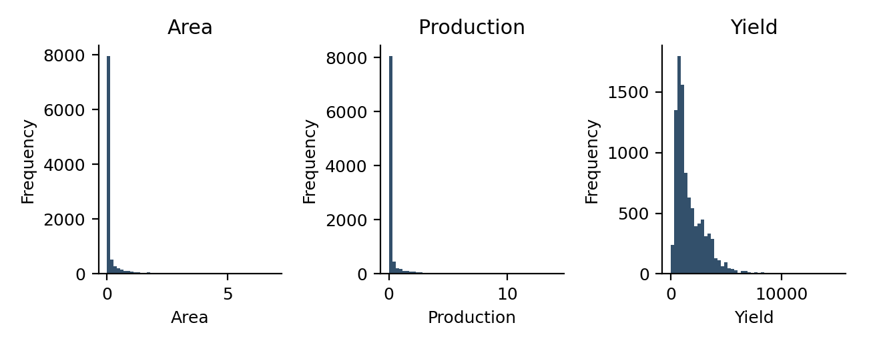
Figure 6. Distributions of Area, Production and Yield in the ML-oriented dataset before transformation: Area and Production are concentrated near zero with long right tails, and Yield is closer to bell-shaped with a right tail.

12.2 Choice of log1p
A skewed variable with a long tail can give a few large values disproportionate weight in models that are sensitive to magnitude, such as linear models, distance-based methods and neural networks. The notebook applied
log1p(x) = log(1 + x)
to all three columns with numpy.log1p. A plain logarithm is undefined at 0, and 4,570 of the 9,795 ML-oriented records (46.7%) have an Area of exactly 0.00. log1p(0) = 0 keeps zeros as zeros, and for small values log1p(x) is close to x, so near-zero records change little while large values are compressed strongly. The count of zero-Area records was obtained from the CSV for this report.

12.3 Before/after transformation analysis
Table 22. Skewness before and after log1p transformation
Variable | Before | After | Absolute reduction | Interpretation
Area-2024-25 | 4.9450 | 3.0746 | 1.8704 | Reduced, but still strongly right-skewed
Production-2024-25 | 5.0871 | 2.9391 | 2.1480 | Largest reduction; still strongly right-skewed
Yield-2024-25 | 1.8942 | -0.9452 | 0.9490 | Magnitude reduced; sign changed from positive to negative

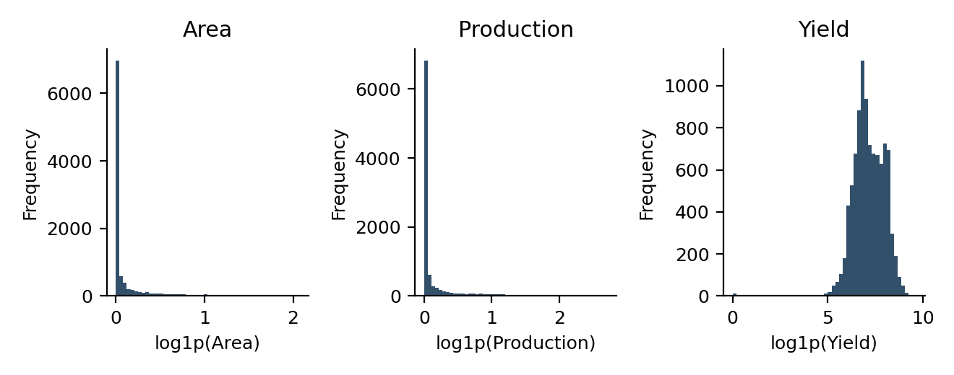
Figure 7. Distributions of Area, Production and Yield after log1p transformation: the upper tails of Area and Production are compressed but both keep a large spike at zero, and Yield now has a longer lower tail.
Area and Production. Skewness fell by 1.87 and 2.15, a clear improvement, yet both remain close to 3. The reason is visible in Figure 7: the large group of zero or near-zero records still forms a spike, and a logarithm cannot spread values that are equal. The transformation reduced the influence of the long tail. It did not make these variables normally distributed.
Yield. Skewness moved from +1.89 to -0.95. The absolute value halved, but the long tail is now on the low side. A likely contributor is the 13 records with a Yield of 0 in the ML-oriented dataset (counted from the CSV), since log1p(0) = 0 lies far below log1p of typical yields of 1,000 to 3,000 (values near 7 to 8). This explanation is an inference and was not tested separately in the notebook. The standardized minimum of -8.85 (Section 13) is consistent with it.
The notebook also plotted box plots before and after the transformation for each variable. They show the maxima pulled much closer to the bulk of the data; for Production the maximum falls from about 14 to below 3 on the log scale. These plots remain in the notebook.

13. Standardization
The log-transformed columns were then scaled with scikit-learn's StandardScaler. This is standardization and not min-max normalization: each column has its mean subtracted and is divided by its standard deviation, so it ends with mean approximately 0 and standard deviation approximately 1. Min-max normalization would instead map values into a fixed range such as 0 to 1, and was not applied.
z = (x − μ) / σ
Scale matters because Area and Production span roughly 0 to 14 while Yield reaches 15,033. After the log transform the ranges are closer but still unequal, and in distance-based or gradient-based algorithms the column with the largest numerical spread tends to dominate. After standardization a unit change means one standard deviation in every column.
Table 23. Numerical variables after log1p and standardization (notebook output)
Variable | Mean | Std (pandas) | Min | Max | Skewness
Area-2024-25 | 9.29e-17 | 1.0001 | -0.4468 | 8.3522 | 3.0746
Production-2024-25 | 3.77e-17 | 1.0001 | -0.4405 | 6.0135 | 2.9391
Yield-2024-25 | 9.63e-16 | 1.0001 | -8.8524 | 3.0490 | -0.9452

The means are zero to within floating-point error. The standard deviation reads 1.000051 in pandas because StandardScaler divides by the population standard deviation, while DataFrame.std() computes the sample standard deviation; for n = 9,795 the ratio is the square root of 9,795/9,794, which is 1.000051. Skewness is unchanged by standardization, as expected for a linear rescaling. The minimum standardized values of Area (-0.4468) and Production (-0.4405) correspond to the zero records, and the maximum Area of 8.35 is more than eight standard deviations above the mean, a reminder that the variables remain heavy-tailed.

14. Final ML-Ready Feature Matrix
The final dataset joins the 772 one-hot encoded columns to the three standardized numerical columns on the shared row index, giving 9,795 rows and 775 columns. It is a preprocessed ML-oriented feature matrix, not a supervised-learning training dataset. No target variable was selected in Week 2. Target selection, train/test partitioning and leakage-safe fitting of the preprocessing transformers remain subsequent modelling steps.

14.1 Feature lineage
Table 24. Feature lineage from original columns to the final matrix
Original feature | Processing | Final representation
State | One-hot encoding | 31 State_* features
District | One-hot encoding | 723 District_* features
Crop | One-hot encoding | 15 Crop_* features
Season | One-hot encoding | 3 Season_* features
Area-2024-25 | log1p, then StandardScaler | 1 numerical feature
Production-2024-25 | log1p, then StandardScaler | 1 numerical feature
Yield-2024-25 | log1p, then StandardScaler | 1 numerical feature
Total |  | 775 columns

In the final CSV the 772 encoded columns come first, in the order State, District, Crop, Season (alphabetical within each block), followed by the three numerical columns. Representative feature names:
Table 25. Representative encoded feature names (first, second and last of each block)
Block | Feature names
State_* | State_Andaman And Nicobar Islands, State_Andhra Pradesh, State_West Bengal
District_* | District_Adilabad, District_Agar-Malwa, District_Zunheboto
Crop_* | Crop_Bajra, Crop_Barley, Crop_Wheat
Season_* | Season_Kharif, Season_Rabi, Season_Summer

14.2 Final dataset composition
Table 26. Composition of the final feature matrix
Component | Count
Rows | 9,795
One-hot encoded categorical features | 772 (State 31, District 723, Crop 15, Season 3)
Standardized numerical features | 3 (Area, Production, Yield; log1p then StandardScaler)
Total columns | 775
Target variable | None selected

14.3 Sample of the final CSV
The table shows eight rows of the final CSV and seven of its 775 columns. The "source record" column was reconstructed by repeating the notebook's filter on the raw CSV, since the final CSV carries no identifying labels; the original raw row index is given for traceability. Area, Prod. (Production) and Yield are the standardized values.
Table 27. Sample rows of the final ML feature matrix (7 of 775 columns)
Row | Source record | State_ Punjab | District_ Ludhiana | Crop_ Rice | Season_ Kharif | Area | Prod. | Yield
0 | Nicobars / Rice / Kharif (Andaman And Nicobar Islands) [raw row 0] | 0 | 0 | 1 | 1 | -0.4468 | -0.4405 | -0.6841
6315 | Ludhiana / Rice / Kharif (Punjab) [raw row 16284] | 1 | 1 | 1 | 1 | 4.9793 | 5.7346 | 1.6396
6316 | Ludhiana / Wheat / Rabi (Punjab) [raw row 16286] | 1 | 1 | 0 | 0 | 4.7598 | 5.7186 | 1.7193
6375 | Sangrur / Rice / Kharif (Punjab) [raw row 16488] | 1 | 0 | 1 | 1 | 4.7723 | 5.6016 | 1.6501
6321 | Ludhiana / Moong / Summer (Punjab) [raw row 16301] | 1 | 1 | 0 | 0 | -0.2392 | -0.3245 | -0.2790
9323 | Unnao / Maize / Kharif (Uttar Pradesh) [raw row 23954] | 0 | 0 | 0 | 1 | 0.1478 | 0.2197 | 0.6876
6525 | Bikaner / Other Pulses / Rabi (Rajasthan) [raw row 16917] | 0 | 0 | 0 | 0 | -0.4468 | -0.4405 | 3.0490
9784 | Uttar Dinajpur / Wheat / Rabi (West Bengal) [raw row 25208] | 0 | 0 | 0 | 0 | 0.0354 | 0.2731 | 1.0318

14.4 What "ML-ready" means in this project
In this report "ML-ready" means that the data have been preprocessed into a numerical form compatible with downstream machine-learning workflows. It does not mean that a target has been defined, that a train/test split has been performed, that a model has been trained, or that leakage has been eliminated. The final file is Agricultural_ML_Ready_Week2.csv, 30,853,542 bytes (29.42 MiB), verified to exist and to match the pipeline output (Appendix C).

15. Final Validation
The final matrix was validated in the notebook (missing, infinite and duplicate checks, shape and scaling statistics). During report preparation the supplied final CSV was also reloaded and checked independently, and the whole pipeline was re-run on the raw CSV. Detailed results are in Appendix C.
Table 28. Final validation of the ML-ready feature matrix
Check | Result | Status | Performed in
Missing values | 0 | Passed | Notebook and final CSV
Infinite values | 0 | Passed | Notebook and final CSV
Duplicate rows | 0 | Passed | Notebook and final CSV
Final dimensions | 9,795 rows × 775 columns | Verified | Notebook and final CSV
Numerical scaling | Means about 0 (1e-16 order); standard deviation 1.000051 (sample), 1 (population) | Verified | Notebook and final CSV
Encoded columns | 772 columns, values only 0 or 1, exactly four 1s per row | Passed | Final CSV (report preparation)
Feature structure | 31 State_*, 723 District_*, 15 Crop_*, 3 Season_*, then 3 numerical columns | Verified | Final CSV (report preparation)
Reproducibility | Final CSV reproduced from the raw CSV; encoded block identical, numerical difference at most 2.7e-15 | Verified | Report preparation
Output file | Agricultural_ML_Ready_Week2.csv, 29.42 MiB | Saved | Notebook and final CSV

These checks show that the matrix is complete, finite, duplicate-free and consistent with the documented pipeline. They do not show that it is suitable for any particular model.

16. Before and After Summary
Table below gives the whole transformation at a glance, with each metric measured at the stage where it is defined.
Table 29. Raw, cleaned, ML-oriented and final datasets compared
Metric | Raw | Cleaned | ML-oriented | Final
Rows | 25,239 | 25,192 | 9,795 | 9,795
Columns | 7 | 7 | 7 | 775
Missing cells | 94 (47 rows) | 0 | 0 | 0
Duplicate rows | 0 | 0 | 0 | 0
States / districts | 31 / 723 | 31 / 723 | 31 / 723 | 31 / 723 (encoded)
Crop labels | 19 | 19 | 15 | 15 encoded
Season values | 4 | 4 | 3 | 3 encoded
Aggregate-crop records | 8,115 | 8,113 | 0 | not applicable
Total-season records | 10,163 | 10,143 | 0 | not applicable
Categorical features | 4 | 4 | 4 | 772 encoded
Numerical features | 3 | 3 | 3 | 3 standardized
IQR outliers (Area / Prod. / Yield) | not computed | 3,903 / 4,299 / 485 | not computed | not computed
Skewness (Area / Prod. / Yield) | not computed | 3.7454 / 3.8706 / 1.4941 | 4.9450 / 5.0871 / 1.8942 | 3.0746 / 2.9391 / -0.9452
Numerical transformation | None | None | None | log1p + StandardScaler

The raw counts of aggregate and Total-season records (8,115 and 10,163) are the cleaned counts plus the records among the 47 removed ones (2 and 20); they were computed from the CSV. The cleaned and ML-oriented skewness values are the notebook outputs. The drop in rows from the cleaned to the ML-oriented dataset (25,192 to 9,795) is a change of representation, whereas the drop from raw to cleaned (25,239 to 25,192) is data cleaning.

17. Key Analytical Findings
Each finding is paired with what it means for the work that follows.
Table 30. Findings and their interpretation
Finding | Interpretation
Missingness: 47 of 25,239 records (0.19%) lack Production and Yield; 43 have Area 0.00 and 4 have Area 0.04 or 0.05. | The gaps are concentrated where the source reports no output, so they are structural and not random noise. Removal loses little and avoids invented values.
Structural aggregation: aggregate crops are 8,113 records (32.2%) and Total-season rows 10,143 (40.26%); for the 7,284 individual-crop Total rows, Area and Production equal the seasonal sums within 0.02. | The raw layout mixes several levels of aggregation. Using it unchanged would count the same production repeatedly, so a non-overlapping representation is needed for modelling.
Outliers: IQR flags 3,903 Area, 4,299 Production and 485 Yield values. | A statistical flag is not an error. The fences are narrow because most values are near zero, and the largest values are district totals. Skew is better treated by transformation than by deletion.
Group comparison: individual-crop records have the higher flag rate (17.20% for Area against 6.80% for aggregates). | The flag rate depends on the distribution within each group; aggregation alone does not explain the outliers.
Extreme Yield values arise where Area and Production are below reporting precision. | Yield is unreliable on tiny bases. These records need source verification before being trusted in a Yield model.
Skewness: 4.9450, 5.0871 and 1.8942 fall to 3.0746, 2.9391 and -0.9452 after log1p. | The tail is compressed but Area and Production remain right-skewed because of the zero spike; Yield now leans left.
High cardinality: District generates 723 of 772 encoded features (93.7%). | District dominates the categorical dimensionality and may call for regularization, grouping or an alternative encoding in later modelling.
Final dimensionality: 9,795 rows × 775 columns, stored densely with 0.52% non-zero entries. | The matrix is wide relative to its three numerical features. Memory and algorithm choice should take this into account.
Data integrity: 0 missing, 0 infinite and 0 duplicate values, and the final CSV is reproduced from the raw CSV. | The file is a faithful output of the documented pipeline. It is not yet a leakage-safe training set.

18. Challenges and Decision Log
Table 31. Decision log
Challenge | Evidence | Decision | Rationale
Missing Production and Yield | 47 rows, 94 cells; Area 0.00 in 43 rows and 0.04 to 0.05 in 4 | Remove the 47 rows | No source value to estimate from; imputing would invent data; 0.19% loss
Aggregate crop categories | 8,113 records (32.2%) at a different aggregation level | Keep in the cleaned dataset; exclude from the ML-oriented dataset | They overlap with individual-crop rows, so they would duplicate production
Total season | 10,143 records; 7,284 of 7,284 individual-crop Total rows equal the seasonal sums | Keep in the cleaned dataset; exclude from the ML-oriented dataset | Total repeats production already recorded by season
IQR outliers | 3,903 / 4,299 / 485 flagged; largest values are district totals | Retain all; treat skew by transformation | A flag is not an error; deleting would remove real production
Nominal categorical variables | 31 states, 723 districts, 15 crops, 3 seasons | One-hot encoding with handle_unknown="ignore" | Avoids implying an order; tolerates unseen categories later
High District cardinality | 723 of 772 encoded features | Accept the width in Week 2 | Choice of reduction depends on the future model and target
Skewed, zero-heavy numerical columns | Skewness 4.9450, 5.0871, 1.8942; 46.7% of Area values are 0 | Apply log1p | Defined at zero and compresses the right tail
Different numerical scales | Area and Production up to about 14, Yield up to 15,033 | StandardScaler on the log-transformed columns | Gives each column mean 0 and standard deviation 1
Scope of fitting | Encoder and scaler fitted on all 9,795 rows | Disclose as a limitation | Acceptable for a preprocessing exercise; not leakage-safe for model evaluation

19. Relevance to Machine Learning
This section describes possible uses of the feature matrix. It reports no model results, because no model was trained in Week 2. The preprocessing completed so far is preparation, not evaluation. Potential target variables are Yield or Production; Area is better treated as a predictor, though that depends on the question asked (Section 20).
- Crop yield prediction. District, state, crop and season are available as features, with Yield a candidate target. Section 20 explains why Area and Production then need special handling.
- Production prediction or estimation. With Production as target, Area and the categorical features can show how much of production is explained by cultivated area and location. This is same-year estimation and not forecasting, which would need a future-time setup defined across years.
- District-level agricultural productivity modelling. The District encoding lets a model learn location effects, though with 723 districts and one year of data many districts have few records per crop.
- Agricultural pattern analysis. Grouping the matrix by crop, season or state can reveal patterns in productivity, such as how Yield differs between Kharif and Rabi crops, without a predictive model.
- Crop comparison and decision support. The cleaned source dataset retains the aggregates for reporting, while the ML-oriented subset supports crop-level modelling.

20. Data Leakage and Future Modeling Considerations

20.1 Target leakage among Area, Production and Yield
Yield is derived from Production and Area. With Area and Production in the same scale, Yield is proportional to their ratio:
Yield ≈ Production / Area (up to a unit-dependent constant)
In the supplied file, Production divided by Area, multiplied by 1,000, reproduces Yield within 5% for all 2,980 cleaned rows with Area of at least 1.0, so the relationship is real and not hypothetical. If Yield is chosen as the target, using Area and Production as predictors lets a model reconstruct the target almost exactly, which is leakage and not learning. The same holds if Production is the target and Yield and Area are predictors. The three numerical columns therefore cannot all be treated as independent features, and target-specific feature selection is required before modelling.

20.2 Preprocessing leakage and the correct workflow
If the matrix is later used for supervised learning, the order of operations matters:
- Choose the target and the feature set, taking the relationship above into account.
- Split the data into training, validation and test sets before fitting any transformation.
- Fit the one-hot encoder only on the training data.
- Fit the scaler (after log1p) only on the training data.
- Transform the validation and test sets with the fitted encoder and scaler, without refitting them.

20.3 Status in Week 2
The Week 2 notebook fitted the OneHotEncoder and StandardScaler on the complete ML-oriented dataset of 9,795 rows. The scaler's means and standard deviations, and the encoder's category list, therefore include rows that would later belong to a validation or test set. This is acceptable for a preprocessing exercise, but the output must not be described as leakage-safe training preprocessing. No train/test split, target selection or model training was performed.

21. Limitations
- Full-dataset fitting. The encoder and scaler were fitted on the complete ML-oriented dataset. In a production ML workflow, preprocessing must be fitted on the training partition only and then applied to validation and test data to prevent data leakage.
- No train/test split and no model validation. No model was trained, so the benefit of the transformations for predictive performance is untested. The evidence offered is statistical (skewness and scale).
- No target variable. The final output is a feature matrix. Target selection and target-specific feature selection are open.
- Single agricultural year. The data cover 2024-25 only, so trends and year-to-year variation cannot be studied.
- Provenance only partly verified. The file matches a published resource credited to DA&FW on a secondary host (27 of 27 rows compared), but the primary portal, download date and full-file equivalence are unconfirmed.
- Units not confirmed at source. They are stated by the host and consistent with the Yield relationship, but were not checked against primary documentation.
- Zero-heavy Area distribution. 46.7% of ML-oriented rows have an Area of exactly 0.00, which limits what log1p can achieve and leaves Area and Production strongly skewed.
- Low-precision values. Area and Production appear to be rounded to two decimals, as 8,603 of 8,620 zero-Area rows have a positive Yield. Yield computed from tiny, rounded bases is unreliable.
- High-dimensional one-hot representation. 772 columns, 723 from District, stored densely with 0.52% non-zero entries, may suit some algorithms poorly; no reduction was tried.
- Unverified extreme Yield values. Yield values such as 15,033 for Other Pulses in Bikaner were retained but not checked against the source.
- Derived relationship between Area, Production and Yield. The three numerical columns are not independent, which affects model design.
- Traceability of the final CSV. The final CSV has no State, District, Crop or Season labels and no row identifier, only the one-hot columns in the ML-oriented dataset's row order, so mapping a row back to a source record requires re-running the filter.
- Label checks were limited. Whitespace and case were tested; other spelling variants and an official district list were not.

22. Conclusion
The raw crop file proved to be in better condition than its size suggested. Only 47 of 25,239 records were incomplete, the labels were consistent and there were no duplicates. The more important finding was structural: nearly a third of the cleaned records are aggregate crop categories and 40% are Total-season rows, and the Total rows reproduce the seasonal figures for every individual crop. A model trained on the raw layout would have learned from duplicated, mixed-level observations.
The main decisions followed from the evidence. Incomplete records with no production figures were removed because imputing them would invent values. The IQR outliers were investigated and kept, because the largest values are district totals and the flag rate reflects a zero-heavy distribution. Aggregate and Total-season records stayed in the cleaned source dataset but were excluded from the ML-oriented one, leaving 9,795 non-overlapping rows. The categorical variables became 772 one-hot features, and the numerical variables were log-transformed and standardized, which reduced skewness but did not remove it.
The final feature matrix has 9,795 rows and 775 columns, with no missing, infinite or duplicate values, and it was reproduced exactly from the raw CSV. It is the input for later modelling work, not a finished training set. The next stage must choose a target, split the data, refit the encoder and scaler on the training partition only, and treat Area, Production and Yield with the leakage relationship in mind.

References
- Global Agriculture (Krishak Jagat). Latest Agriculture Statistics of India: All India: District and Crop wise Area, Production & Yield of All Crops (2024-25), file DES-District-Data-For-2024-25.csv; source credited to DA&FW. https://www.global-agriculture.com/latest-agriculture-statistics-of-india/. Accessed 25 October 2026.
- Crop Data 24-25.csv. District-level crop area, production and yield, 2024-25. File supplied for the Yuva Intern project.
- Yuva Intern. Week 2 task description: data preprocessing, cleaning and transformation (Junior Machine Learning Data Analyst, Agriculture & Agribusiness). Supplied with the project materials.
- Agriculture_Data_Preprocessing_Week2.ipynb. Google Colab notebook by the author containing the code and outputs reported here.
- The pandas development team. pandas documentation. https://pandas.pydata.org/docs/
- NumPy developers. numpy.log1p. https://numpy.org/doc/stable/reference/generated/numpy.log1p.html
- scikit-learn developers. sklearn.preprocessing.OneHotEncoder. https://scikit-learn.org/stable/modules/generated/sklearn.preprocessing.OneHotEncoder.html
- scikit-learn developers. sklearn.preprocessing.StandardScaler. https://scikit-learn.org/stable/modules/generated/sklearn.preprocessing.StandardScaler.html
- Matplotlib development team. Matplotlib documentation. https://matplotlib.org/stable/

Appendix A. Selected Preprocessing Code
The excerpts are condensed from the Colab notebook. The full notebook is not reproduced.

A.1 Missing-value treatment
df_clean = df.copy()
df_clean = df_clean.dropna(subset=["Production-2024-25", "Yield-2024-25"])
print("Rows removed:", len(df) - len(df_clean)) # 47

A.2 IQR outlier summary
for column in numerical_columns:
Q1 = df_clean[column].quantile(0.25)
Q3 = df_clean[column].quantile(0.75)
IQR = Q3 - Q1
lower_bound = Q1 - 1.5 * IQR
upper_bound = Q3 + 1.5 * IQR
outliers = df_clean[(df_clean[column] < lower_bound) |
(df_clean[column] > upper_bound)]

A.3 ML-oriented dataset
aggregate_crops = ["Total Food Grains", "Cereals",
"Nutri/Coarse Cereals", "Total Pulses"]
df_ml = df_clean[(~df_clean["Crop"].isin(aggregate_crops)) &
(df_clean["Season"] != "Total")].copy() # 9,795 rows

A.4 Encoding, log transformation and standardization
encoder = OneHotEncoder(handle_unknown="ignore", sparse_output=False)
encoded_array = encoder.fit_transform(df_ml[categorical_columns]) # 772 columns

df_log = df_numeric.copy()
for column in numerical_columns:
df_log[column] = np.log1p(df_log[column])

scaler = StandardScaler()
scaled_array = scaler.fit_transform(df_log)

df_ml_ready = pd.concat([df_encoded, df_scaled], axis=1) # 9,795 x 775

A.5 Final validation
print("Missing values:", df_ml_ready.isnull().sum().sum()) # 0
print("Infinite values:", np.isinf(df_ml_ready).sum().sum()) # 0
print("Duplicate rows:", df_ml_ready.duplicated().sum()) # 0

Appendix B. Supplementary Tables
Table 32. Missing records by crop (47 records)
Crop | Records
Ragi | 8
Moong | 7
Lentil | 6
Bajra | 4
Jowar | 4
Tur | 4
Barley | 2
Nutri/Coarse Cereals | 2
Gram | 2
Small Millets | 2
Maize | 2
Shree Anna /Nutri Cereals | 2
Urad | 1
Other Pulses | 1

Table 33. Missing records by state (47 records)
State | Records
Chhattisgarh | 14
Rajasthan | 11
West Bengal | 5
Bihar | 5
Uttar Pradesh | 4
Arunachal Pradesh | 2
Himachal Pradesh | 2
Jharkhand | 2
Madhya Pradesh | 2

Table 34. Crop frequencies in the cleaned dataset (n = 25,192)
Crop | Records | Type
Total Food Grains | 2,597 | Aggregate
Cereals | 2,525 | Aggregate
Nutri/Coarse Cereals | 2,292 | Aggregate
Maize | 2,026 | Individual
Rice | 1,792 | Individual
Moong | 1,678 | Individual
Urad | 1,493 | Individual
Shree Anna /Nutri Cereals | 1,459 | Individual
Other Pulses | 1,203 | Individual
Wheat | 1,062 | Individual
Tur | 1,040 | Individual
Gram | 1,014 | Individual
Jowar | 963 | Individual
Bajra | 875 | Individual
Total Pulses | 699 | Aggregate
Small Millets | 682 | Individual
Lentil | 674 | Individual
Ragi | 580 | Individual
Barley | 538 | Individual

Table 35. Crop frequencies in the ML-oriented dataset (n = 9,795)
Crop | Records
Maize | 1,353
Rice | 1,110
Moong | 1,039
Urad | 919
Shree Anna /Nutri Cereals | 836
Other Pulses | 722
Jowar | 553
Wheat | 531
Tur | 520
Gram | 507
Bajra | 468
Small Millets | 341
Lentil | 337
Ragi | 290
Barley | 269

Appendix C. Raw-to-Final Dataset Verification

C.1 Verification of the final CSV
The supplied final CSV, Agricultural_ML_Ready_Week2.csv, was loaded independently and checked, instead of repeating the notebook's print statements. The raw CSV was also run through the documented pipeline to see whether the final file is reproducible.
Table 36. File-level verification of the final CSV
Check | Result
File name | Agricultural_ML_Ready_Week2.csv
File size | 30,853,542 bytes (29.42 MiB; the notebook's 29.42 "MB" is bytes divided by 1,024²)
Shape | 9,795 rows × 775 columns
Data types | All 775 columns float64 when loaded with pandas
Missing values | 0
Infinite values | 0
Duplicate rows | 0

Table 37. Verification of the 772 one-hot columns
Check | Result
Feature-name structure | 31 State_*, 723 District_*, 15 Crop_*, 3 Season_*
Values present | Only 0 and 1
Ones per row | Exactly 4 in every row (one per categorical column)
Columns with no 1 anywhere | 0 (smallest column sum 1, largest 5,186 for Season_Kharif)
Proportion of non-zero entries | 0.52% (4 of 772 per row); stored densely

Table 38. Verification of the three numerical columns in the final CSV
Variable | Mean | Std (sample) | Std (population) | Min | Max | Skewness
Area-2024-25 | 1.16e-16 | 1.000051 | 1.000000 | -0.4468 | 8.3522 | 3.0746
Production-2024-25 | 7.54e-17 | 1.000051 | 1.000000 | -0.4405 | 6.0135 | 2.9391
Yield-2024-25 | 9.58e-16 | 1.000051 | 1.000000 | -8.8524 | 3.0490 | -0.9452

The means differ slightly from the notebook's in-memory values (for example 9.29e-17 for Area) because the CSV stores rounded decimal text; every mean is zero to the order of 1e-16, and the population standard deviation is 1 as expected.
Reproducibility. Re-running the pipeline on the raw CSV (drop the 47 incomplete rows, exclude aggregate crops and Total-season rows, one-hot encode with handle_unknown="ignore", apply log1p and StandardScaler) gave the same 772 feature names in the same order, an encoded block identical to the final CSV, and numerical columns that differ from it by at most 2.7e-15. The final CSV is therefore a faithful output of the documented pipeline applied to the supplied raw CSV. Its row order is the order of the ML-oriented dataset; the first five rows correspond to raw rows 0, 6, 8, 15 and 17, as in the notebook output.

C.2 Numerical consistency checklist
Each key figure in the report was compared across the notebook outputs and an independent recomputation from the supplied CSV files. No unresolved discrepancy was found.
Table 39. Numerical consistency checklist
Item | Notebook | Independent recomputation | Agreement
Raw shape | 25,239 × 7 | 25,239 × 7 | Yes
Missing Production / Yield | 47 / 47 | 47 / 47 | Yes
Cleaned rows | 25,192 | 25,192 | Yes
Aggregate-crop records | 8,113 | 8,113 | Yes
Total-season records | 10,143 | 10,143 | Yes
Individual-crop Total-season records | derived (15,397 − 8,113) | 7,284 | Yes
Rows excluded for ML | 15,397 | 15,397 | Yes
ML-oriented rows | 9,795 | 9,795 | Yes
States / districts / crops / seasons (ML) | 31 / 723 / 15 / 3 | 31 / 723 / 15 / 3 | Yes
IQR outliers (Area / Production / Yield) | 3,903 / 4,299 / 485 | 3,903 / 4,299 / 485 | Yes
Outliers by type (individual, Area / Prod. / Yield) | 2,938 / 3,095 / 631 | 2,938 / 3,095 / 631 | Yes
Outliers by type (aggregate, Area / Prod. / Yield) | 552 / 666 / 170 | 552 / 666 / 170 | Yes
Skewness before log1p | 4.9450 / 5.0871 / 1.8942 | 4.9450 / 5.0871 / 1.8942 | Yes
Skewness after log1p | 3.0746 / 2.9391 / -0.9452 | 3.0746 / 2.9391 / -0.9452 | Yes
Encoded features | 772 | 772 | Yes
Final shape | 9,795 × 775 | 9,795 × 775 | Yes
Final missing / infinite / duplicate | 0 / 0 / 0 | 0 / 0 / 0 | Yes
Final file size | 29.42 (MiB) | 30,853,542 bytes = 29.42 MiB | Yes

C.3 Checks performed only during report preparation
Table 40. Checks performed only during report preparation
Check | Result
Raw-data duplicates and uniqueness of State-District-Crop-Season | 0 duplicates; each combination once
Total-season rows against seasonal sums (individual crops) | 7,284 of 7,284 within 0.02
Overlap of aggregate and Total-season rows | 2,859 aggregate Total-season; 5,254 aggregate seasonal
Units: Production/Area × 1,000 against Yield (Area ≥ 1) | 2,980 rows, all within 5%; median deviation 0.14%
Provenance spot check against the hosted file | 27 of 27 Punjab rows identical
Final CSV binary, row-sum and reproducibility checks | All passed (Appendix C.1)

